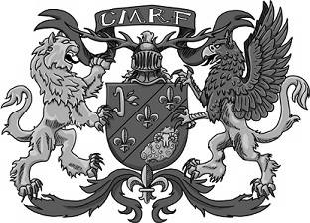
2018 Central Missouri Renaissance Festival
www.centralmorenfest.net
(913) 721-2110
cmrf.vendor@gmail.com
WEEKENDS October 20,21 10am-6pm

Competition – Fantasy Themed

Forms and Murals Due By: October 15, 2018

Please complete the form below and attach it to the back of your Mural. Drop off the Mural at the fair grounds between October 13th - 15th.

Central Missouri Renaissance Festival
I-70 144/Hatton Exit, 4274 County Rd 220, Kingdom City, MO 65262

CONTACT INFORMATION

NAME

ADDRESS

CITY | STATE | ZIP
PHONE |  | EMAIL
ALT. CONTACT  Brief mural description |  | ALT. PHONE

Every entry receives 1 2018 CMRF ticket
One entry per person of INTEREST
- Murals can be brought to the fairgrounds between 10-3pm Oct 13 – 15
✦ Must be 4’ x 8’
- Murals will become property of Central Missouri Renaissance Festival
- Patrons will vote for their favorite mural
✦ Must be painted on a weather-treated material (ex. treated plywood)
- 4’x8’ duck canvas can also be used (must use white canvas only and please put it in a plastic bag when dropping it off)
- Must be painted using outdoor paint or the final mural must be weatherproofed
- Only FAMILY FRIENDLY murals will be accepted/displayed for competition
- 1st PRIZE: 2019 Season Family Pass & CMRF T-shirt
- 2nd PRIZE: 4 2019 CMRF tickets and CMRF T-shirt
- 3rd PRIZE: 2 2019 CMRF tickets and CMRF shot glass

OFFICE USE ONLY:
Mural #: _________________ Ticket #____________________________

